Municipal formation Goryachiy Klyuch city
Glamping accommodation

General description and location of the site

Address: Krasnodar Territory, Goryachiy Klyuch, s. Nameless.
Cadastral number of the plot: 23:41:0706001:1905
Area: 14.4 hectares.
Land category: land of settlements
Type of permitted use: Natural and educational tourism-5.2
Information about the owner: land, state ownership of which is not delimited
Copyright holder: MO Administration
Hot Key

Infrastructure support
Voltage class -10 kW;
Свобо Free power - 0.015 MW;
Ближа Closest point - 2.3 m

Water Supply Source – Need for Drillin Drilling a Well

Gas pipeline: absent

Railway station "Goryacheklyuchevskaya station of the way"JSC "Russian Railways";
Distance – 21 km

Highway FAD “M-Don";
Distance – 10 km.

City Goryachiy Klyuch

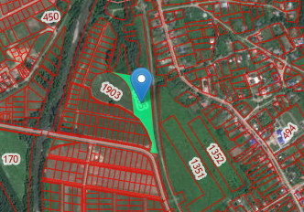

Калин

Contact details
Goryachiy Klyuch city administration
353290, Krasnodar Territory, Goryachiy Klyuch, st. Lenina, 191 Phone / fax: (86159) 3-51-52, 3-86-16. Email address: gor_kluch@mo.krasnodar.ru

